Chapter 1

Introduction

1.1 History:-

Cotton textile production normally takes place in several steps, beginning with ending with finishing. Each step has health and safety risks which are distinct industries into three categories, viz, red, orange and green. Industries under red category and green are identified as the most heavily polluting followed by those in orange category and green category respectively. According to this classification which means industries are prone to produce environmental pollution at an alarming level.

Although textile industry is an old and traditional one, not much attention was paid to the environmental hazards produced by this industry. However with the increasing awareness towards environment issues and labor welfare and attention is being paid to this issue by employers. Machinery manufactures and technologists legal and statutory concerned the hazards are enforced to control the hazards. As far as spinning mill is concerned, the hazards are confined mainly at the work place, i.e. inside the mill and not much outdoor pollution is generated by the spinning. The environment and health hazards at work place in a spinning mill can be classified in two main categories, namely environmental hazards and physical hazards.

Cotton dust and noise are the main environmental hazards which cause health risk in a spinning mail. Out of these two the cotton dust and fly is released in the spinning room environment & contribute maximum to the health hazards of the worker and process hazards such as fire with proper precaution process design training of labor and safety gadgets the physical hazards can be minimized or almost eliminated, however the cotton dust is a continual and persistent problem.

Textile dust is a mixture of organic and inorganic elements in fibrous form. It appears as dust in the form of fine fibers in the air. Occupational exposure occurs in Textile industry and wherever Textile products are used, for instance, in handling cotton/silk/wool used in the textile industry. Exposure may also occur in the textile industry in the manufacture of carpet, thread and clothes.

Textile dust enters the body by inhalation, and fine dust, containing fibers may be deposited in the alveoli. The fibers are insoluble. The dust deposited in the lungs causes fibrosis, pleural plaques, bronchitis and lung cancer. Textile dust results in impaired lung function after long period of exposure. The symptoms are shortness of breath, chest pain, and later bronchitis with increased sputum.

Textile industry is one of the major growth industries for export purpose and which require large number of workers. Respiratory problem is one of the major health threats to textile workers. It leads to some systemic symptoms in exposed workers, along with this they suffer from number of other physical problem like hearing loss or noise problem. (Shake, 1996; Chavalitsakulchai, et al, 1989), low back pain (supplementary report, Industrial health 35, 1997); Respiratory symptoms and pulmonary function (Ming yih et al, 2003); Bysonosis diseases (Shamssain and Shamsian, 1996; Zuskin, et al, 1990; Kogali, Mustafa, 1995) colourvision dysfunction in long term solvent (Dye) exposure, (Ihrig, et al, 2002). In the present paper an attempt has been made to study the effect of dust on lung functions and body morphology of the textile workers, District Varanasi, Uttar Pradesh.

Respiratory diseases are characterized by variable airflow limitation and airway hyper-responsiveness. Once sensitized, exposure to very small concentration of the substance will cause a reaction. The long term effects can be significant in terms of employability. Even if redeployment is possible, employment is lesser skilled jobs and reductions in income are often the outcomes. With the lung function affected for a prolonged exposure to the industrial environment, the nutritional status and body soft tissue stores are also affected the heath status of the Industrial workers.

The textile industry in itself is a big determinant of the overall health and well being of its workers. It provide job opportunities but with a price tag. Tough dust has been establish as the causative agent for respiratory problems, it is important to determine the other risk factors associated with the occurrence of disease so as to implement comprehensive preventive measures.

There is need for textile mills to reduce the dust levels in the scouring, spinning and weaving sections. Hence the dust cleaner equipment helps to reduce the dust to enter through breathing in lungs and creates healthy environment.

* 1. **Problem Definition:-**

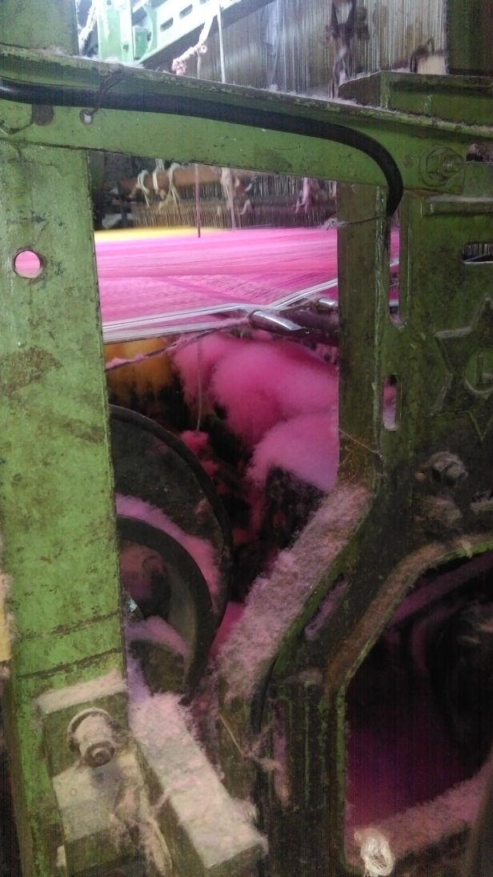Safety and health of workers is important for smooth and effective functioning of any organization. There are numerous risk factors at workplace that can affect workers health. Comfort and performance in one or more ways. Typical health effects of working environment are headache, fatigue, impaired vision, hearing loss and breathing problems and reduced work performance. In textile industry where the worker performs task in a sitting/standing position, static and awkward postures, and duration of work, furniture design and adequate rest pause are the most often associated with the occurrence of serious MSDs. Health effects may show up year exposure or after repeated or long exposure. Due to increasing complexity of occupational health and safety problems, there is a need to specify more and more aspect of work place and work environment to reduce such health problems. From this project we have observed that the workers are exceeding the working limit (8hr to 11hr) and through the working hour is more than the limit for each worker, the value of the pollutant is not accurately exceeding the permissible exposure limit but almost closer to whose effects, in case of a continuous exposure might lead to severe negative impacts.

**Figure 1.1 shows dust particle collected on machine**

* 1. **Health Hazard:-**

Exposure to dust and fibers:-

The exposure of worker to dusts from material such as silk, cotton, wool, flax, hemp, sisal, and jute can occur during weaving, spinning, cutting, ginning, and packaging. Division of task along gender lines may mean that women are exposed to organic dusts more than men, with respiratory disease being diagnosed more often in women than men. Exposure to fibers and yarns may cause nasal or bladder cancer.

Workers exposed to cotton dust laden environment generally become patients of Byssinosis.

1. Byssinosis

Bysonosis is a term from a Greek word meaning white thread. It is a breathing disorder that occurs in some individuals with exposure to raw cotton dust. Characteristically, workers exhibit shortness of breath and/or the feeling of chest tightness when returning to work after being in the mill for a day or more. There may be increased cough and phlegm production.

1. Pulmonary Diseases

There is a group of lung diseases called chronic obstructive pulmonary diseases. The diseases in the group are major causes of illness and disability among workers.

The most common types of chronic obstructive pulmonary disease are:

* Chronic bronchitis
* Asthma
* Emphysema

1. Chronic bronchitis

Is a disorder characterized by a cough and sputum lasting for three or more months of the year and recurring year after year.

1. Asthma

It is thought to be an allergic type of response that causes airways to swell and become narrow. There is increased mucous causing a wheezy, “whistly” sound to breathing. Usually both chronic bronchitis and asthma improve when the person is removed from the irritation causing this response.

1. Emphysema

It is the destruction of the delicate walls between the tiny air sacks in the lungs. As the walls are destroyed, the air sacks enlarge and lungs have less ability to supply oxygen to the bloodstream. In emphysema, there is no way to repair the destroyed air sacs.

* 1. **Scope and objective:-**

Objectives:-

# To minimize cost of Manufacturing.

* To have good dust collecting efficiency.
* To create healthy working environment.

Scopes:-

* This project is helpful for textile industries to fulfill today’s strict govt. norms.
* It is quite useful to reduce the health problems associated with breathing among workers.
* Also ensure the healthy work environment.

Chapter 2

Literature Review

[1] Mahesh R Jadhav [ISSN 2278 – 0149 ([www.ijmerr.com](http://www.ijmerr.com)) Vol. 3, No. 4, October, 2014]:- Cyclone is most commonly used device to separate dust particles from gas and dust flow. The project presents design development of cyclone based on CFD along with experimental trials .The present work is based on the performance of flour mill cyclone for different flow rates. In the present investigation the characteristics of flour mill cyclone are studied for various flow rates (inlet velocities) and its effect on performance parameters like pressure drop and efficiency are studied. Cyclone is designed with two symmetrical tangential inlets and a single tangential outlet at the barrel top area where impeller is mounted. The study was performed for gas-solid flow, based on an experimental study available in the literature, where a conventional cyclone model was used. Simulation of flow will be done with the help of CFD software and verification will be done with the help of experimental work. Results showed that these new designs can improve the cyclone performance parameters significantly and very interesting details were found on cyclone fluid dynamics properties.

[2] Qizhen Liu, Yanjing Sun, Lei Jia, Yihua Zhang, and Zhigang Shen [Journal of Clean Energy Technologies, Vol. 3, No. 2, March 2015]:- Power plant A and Power plant B launched the rebuilt pilot project of bag house and power source of electrostatic precipitator in order to further increase the dust removal efficiency in coal-fired power plants and then improve air quality in Shanghai. Results showed that dust reduction rate rose to 69.5% and the concentration of particulate matter dropped to 9.2 mg/m3 after the rebuilt of bag house. On the other hand, dust reduction rate was 48.8% and the concentration of particulate matter was 17.9 mg/m3 after the rebuilt of electrostatic precipitator.

[3] Muhammad I. Taiwo. Mohammed A. Nimadi. And James, B. Mokwa [AJER]:-

Cyclones have often been regarded as low-efficiency collectors. However, efficiency varies greatly with particle size and cyclone design. Advanced design work has greatly improved cyclone performance. This paper have discussed the design parameters required to construct a high performing cyclone through the application of the classical cyclone design, However, the pressure drop in this design does not consider any vertical dimensions as contributing to pressure drop, This is a misleading in that a tall cyclone would have the same pressure drop as a short one as long as cyclone inlets and outlets dimensions and inlet velocities are the same. Texas cyclone design model was used to obtain an accurate pressure drop and sizing of cyclone, The Texas cyclone approach to design cyclones was to initially determine optimum inlet velocities (design velocities) for different cyclone designs, hence using the inlets velocity a cyclone dimension can be determined.

[4] Journal of the Air Pollution Control Association (Charles A. Gallaer & J. W. Schindeler):- For the purposes of this paper, a mechanical dust collector is defined as a device which separates dust in a dry state from gas through the application of inertial and gravitational forces only. The most widely used type of mechanical dust collector is the cyclone, in which centrifugal force plays the major role in effecting the separation of dust from gas. To fully understand the functioning of a cyclone the major flow patterns within a cyclone should be known.

[5] Analysis and Optimization of Cyclone Separators Geometry Using RANS and LES Methodologies by (Khairy Elsayed):- The gas-solids cyclone separator is industrial equipment that has been widely used for more than a century. Due to its industrial relevance, a large number of experimental, theoretical and computational studies have been reported in the literature aimed at understanding and predicting the performance of cyclones in terms of pressure loss and collection efficiency (cut-off diameter). The currently used mathematical models for the prediction of cyclone performance, however, exhibit limited accuracy and generality. Moreover, the cyclone performance can be calculated using the artificial neural networks approach. An alternative approach is to simulate the gas-particle flow field in a cyclone by computational fluid dynamics (CFD).

[6] Theoretical study of cyclone design A Dissertation by Lingjuan Wang: - To design a cyclone abatement system for particulate control, it is necessary to accurately estimate cyclone performance. In this cyclone study, new theoretical methods for computing travel distance, numbers of turns and cyclone pressure drop have been developed. The flow pattern and cyclone dimensions determine the travel distance in a cyclone. The number of turns was calculated based on this travel distance. The new theoretical analysis of cyclone pressure drop was tested against measured data at different inlet velocities and gave excellent agreement. The results show that cyclone pressure drop varies with the inlet velocity, but not with cyclone diameter.

Chapter 3

Industrial Visit for Understanding the Problem

The textile industries in India traditionally after agriculture, is the only industry that has generated huge employment for skilled and unskilled labor in textile. It is the second largest employment generating sector in India. It offers direct employment to over 35 million in the country. The share of textile in total exports was 11.04% during April-July 2010 as per ministry of textile. In 2010 there were 2500 textile weaving factories and 4135 textile finishing.

Factories in all over the India most of workers worked in textile industries worker faces occupational hazards, health hazards. According to survey not only workers but also all family members who lived with him. We have also visited” **Pogul Textile Industry”** situated in Akkalkot road, MIDC, Solapur. We have also collected the sample dust for study of its various physical properties. There was no any provision for collection of dust at all and also visit ravels that many workers are facing respiratory problems like asthma, cough etc. Other facts observed during studies are as follows:

1. Most workers are suffered from headache, shortness of breath, cough.

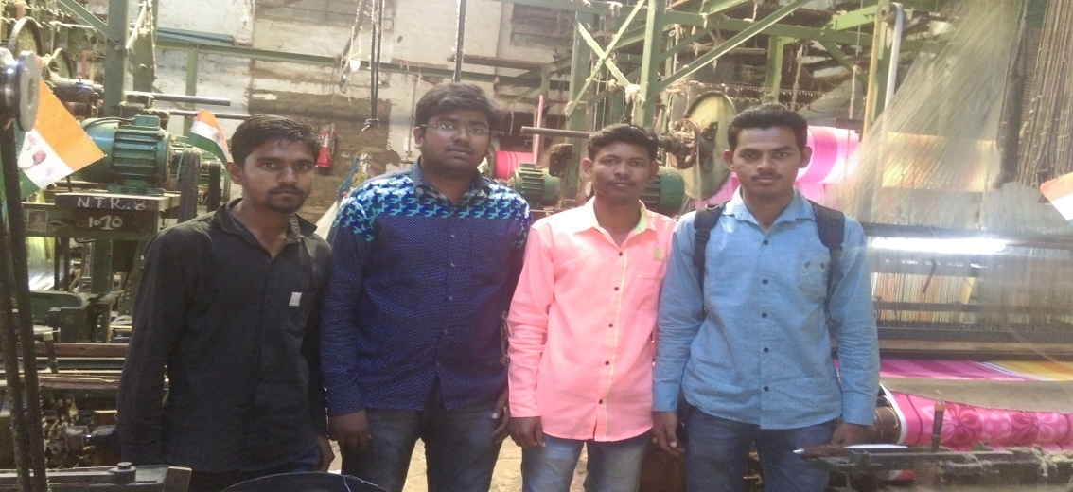2. Some people suffer from lungs cancer so our sample study made clear that the workers faces health hazards, occupational hazards. So that they can take precautionary method by using various options available in the market like mask, scuffs, additional cleaning equipment like vacuum cleaner and dust collector.

Fig 3.1 shows group visit to pogul textile

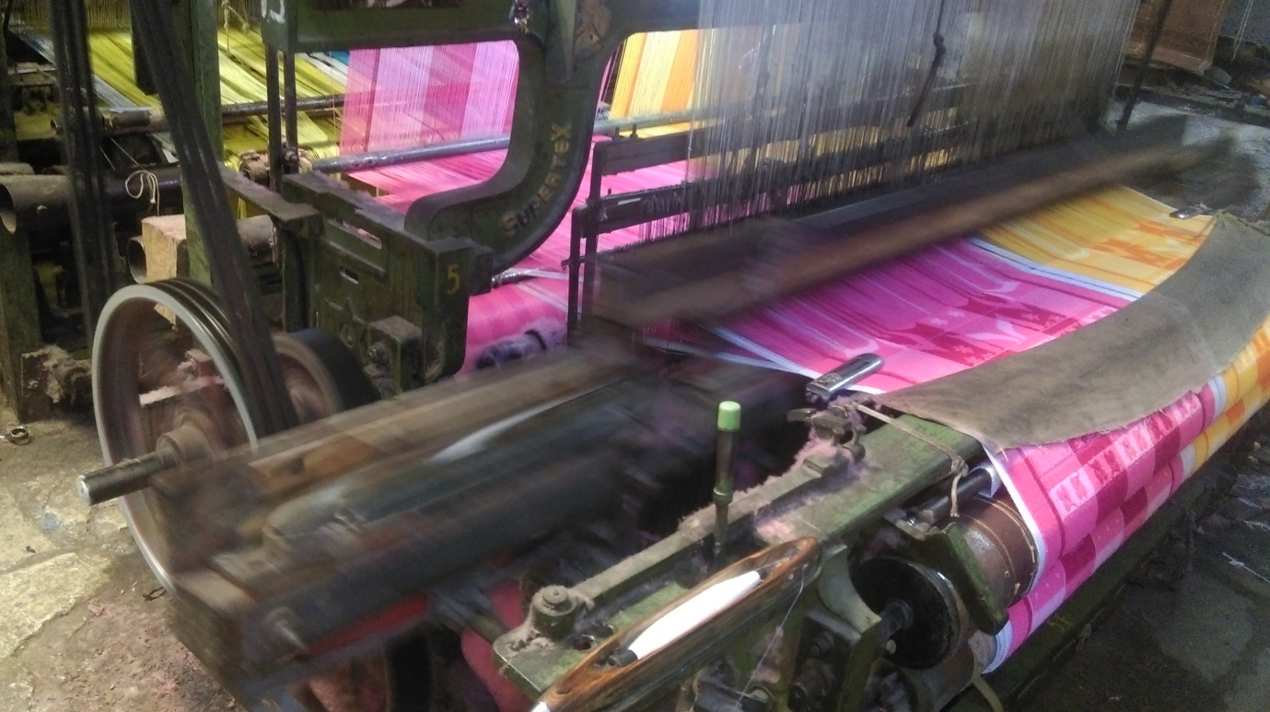Fig 3.2 shows spinning of towels

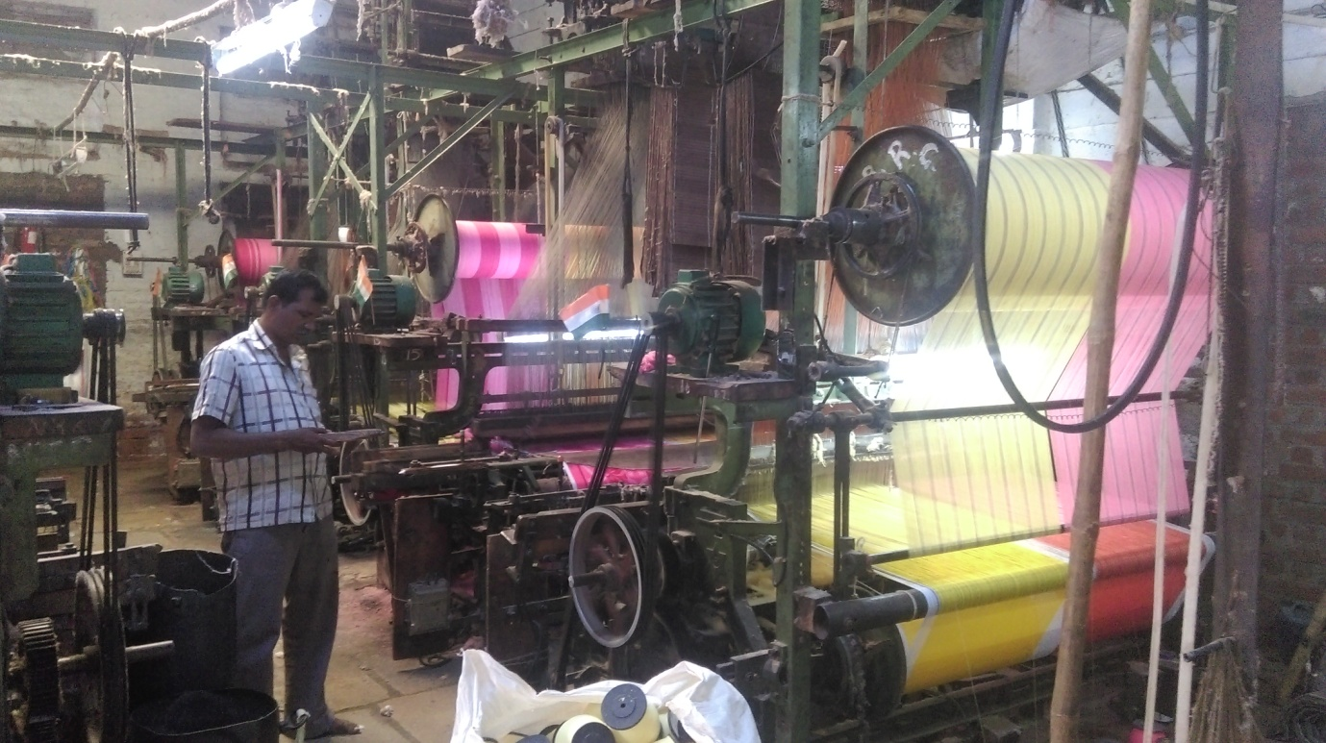

Fig 3.3 shows spinning machines

Chapter 4

Possible solution

As to resolve this problem as stated above possible solutions like masks, scuffs, additional cleaning equipment’s like vacuum cleaner and dust collectors. There are some problems associated with every solution for example in case of mask worker cannot wear it for whole duty time; also each worker has to carry a separate mask. It also makes difficulty while communication among the workers. Additional cleaning equipment like vacuum cleaner adds cost to the industry, again the running cost and requirement of electricity is another problem. Adjust collector available in market are having high cost which cannot be afforded by small scale industries. Most of industries located in Solapur are small scale. So the solution is development of new low cost dust collector which is manufactured with locally available material which can be afforded by small scale industries. We know in developing countries like India we are continuously facing health issues due to lack of literacy and poverty. Most of workers from textile industry are not covered by any health insurance. For this our efforts are to develop cheapest, Low maintenance dust collector for textile industry.

**The following recommendations are suggested for controlling the occupationally lung disease caused by cotton dust:**

* Periodic heath surveillance to be made essential.
* Proper treatment should be given to the affected workers.
* Effected dust control measure to be adopted.
* Awareness to be given for the administrators and the workers.
* Usage of personnel protective equipment should be strongly advised.
* The management should strictly provide and follow control technologies and protective strategies.
* The worker should be aware of the effects of cotton dust and exceeding the working limit.

**Dust controls**

Often employers can reduce dust levels by adjusting dust control equipment, such as ventilation system, and by cleaning and repairing the equipment regularly.

An employer’s dust control program must include, at a minimum, the following:

# 1) Cleaning floors with a vacuum or any others method that cuts down the spreading of dust.

2) Disposing of dust in such a way that as little dust scatters as possible.

3) Using mechanical method to slack dump or otherwise handle cotton or cotton waste, when possible.

4) Checking, cleaning, and repairing dust control equipment and ventilation systems. Employs involved in cleaning must wear respirators. Compressed air may not be used to clean clothing and floors and may only be used to clean equipment if no other methods are possible. If these measures fail to reduce the cotton dust levels below the OSHA limits, employers must try additional engineering controls and work practices.

Chapter 5

Methodology

5.1 material requirements:-

The various material and equipment required are as follows:-

**1. Exhaust Fan:-**

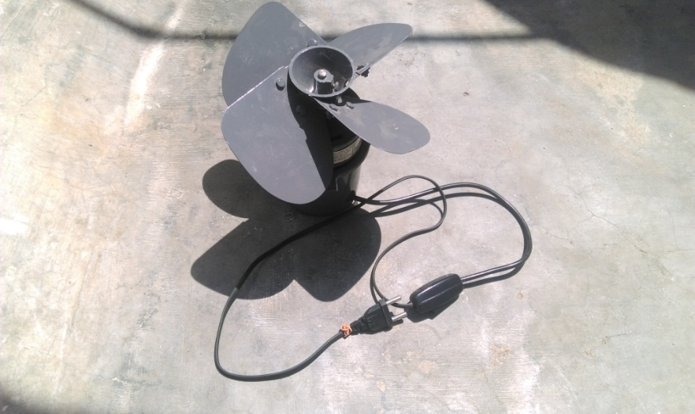 A whole-house fan is a type of fan or exhaust system commonly venting into a building's attic, designed to circulate air in a home or building. It is sometimes confused with a powered attic ventilator, which exhausts hot air from the attic to the outside through an opening in the roof or gable at a low velocity.

Fan is placed inside the casing which is placed on the stand. Fan is used to suck the dust particle and passed to cyclone.

**2 .Cyclone body: - figure 5.1.1 shows exhaust fan**

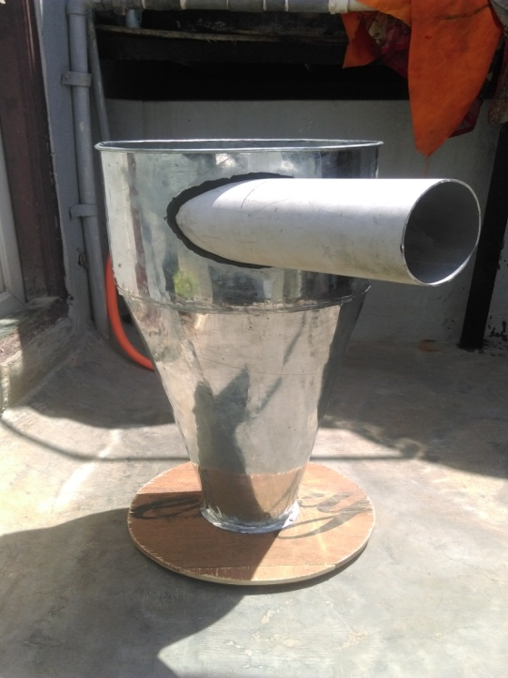 Cyclone produces the separation of the powders due to inertial forces effect moreover; it forces the airflow to de-dust at a helical motion, on itself, inside of a room in development tapered downward. The air moved by a fan enters down from above where it is forced to a circular motion between two concentric walls. It therefore creates into the cyclone a swirling air motion. The solid particles of dust are pushed by centrifugal action against the inner walls of the cylinder body. Gradually, and with continuity, they descend down with spiral motion to the neck of the cyclone to fall within the bin or are discharged through a rotary valve.

**Figure 5.1.2 shows Cyclone Body**

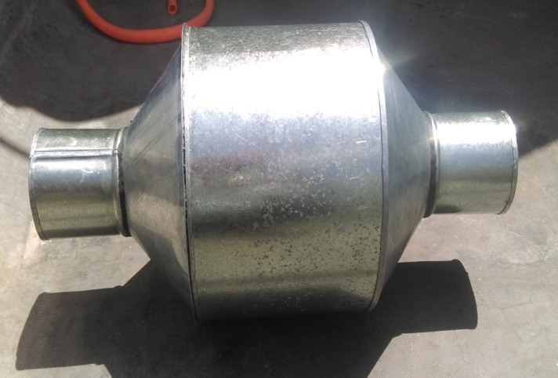 3. Fan casing:-

The cylindrical casing is used in which the exhaust fan is situated to provide protection as well as guide the air to flow in particular direction.

**Figure 5.1.3 shows Fan casing**

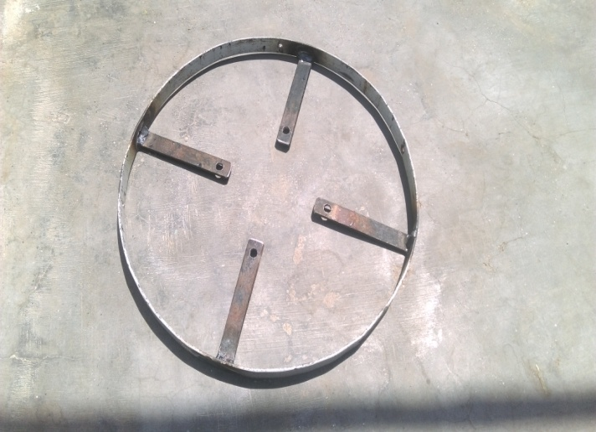

**4. Fan casing ring: -** The fan casing ring helps to support the exhaust fan inside the fan casing. It is made up of the C.I metallic strips which given the shape of the circular ring.

**Figure 5.1.4 shows Fan casing ring**

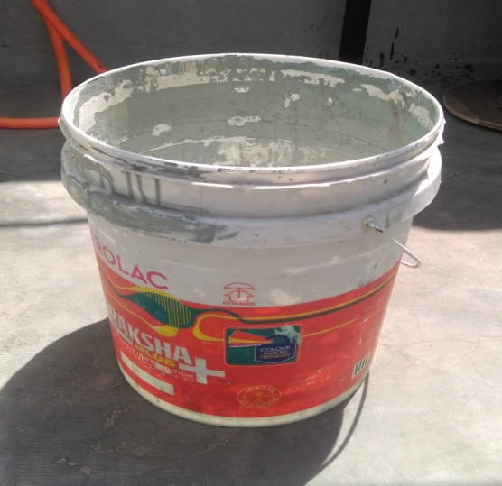5. Collection bucket: - The drum is nothing but the plastic bucket which has dimensions of 305mm in diameter and 356mm height.

**Figure 5.1.5 shows Collection bucket**

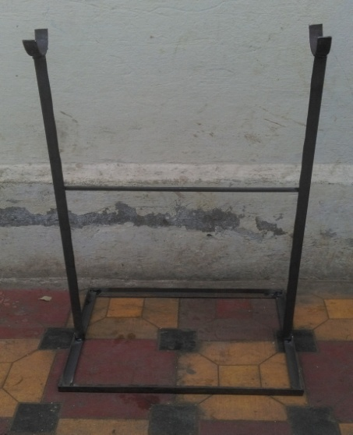6. Supporting stand: - The stand is made up of cast iron rods to support or take load of the fan casing.

Figure 5.1.6 shows Supporting stand

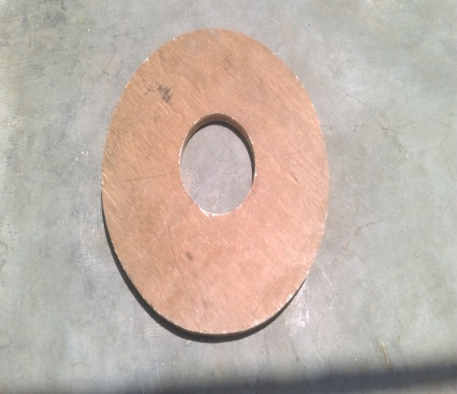7. Wooden plate: - The wooden circular plates are employed to cover the cyclone body at the top and to cover the collecting bucket.

Figure 5.1.7 shows wooden plate

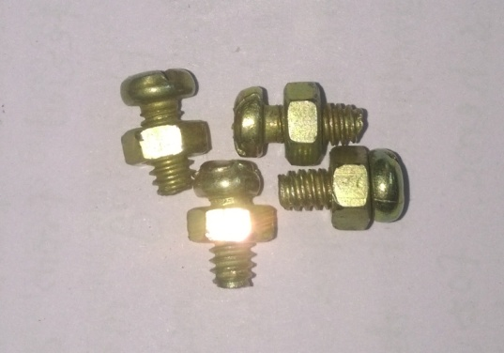8. Nut and bolts: - These mechanical fasteners plays very important role in assembly of the entire component. A nut is a type of fastener with a threaded hole. The bolt consists of a head and a cylindrical body with screw threads along a portion of it length.

Figure 5.1.6 shows Nut and bolts

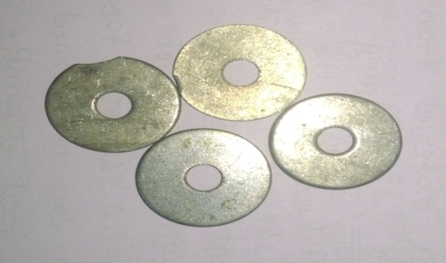

9. Washers: - The washers are used in fastening the bolts in the casing as well as in assembly purpose.

Figure 5.1.8 shows Washers

10. M-Seal: - M-seal is employed to prevent the chances of air leakage.

Table 1.List of material requirement

|  |  |  |  |
| --- | --- | --- | --- |
| Sr no | Name of material | Specification | Quantity |
| 1 | Cyclone body | a) Barrel:-  D= 305 mm  H= 316 mm  b) Cone:-  D= 305 mm  H= mm  d= 114 mm  c) Pipe:-  d= 114 mm | 1 |
| 2 | Exhaust fan | Speed :- 2350 rpm  Blade diameter:- 229 mm | 1 |
| 3 | Fan casing | Dc= 305 mm  di=dex= 114 mm | 1 |
| 4 | Fan casing ring | Dr= 305 mm | 1 |
| 5 | Wooden plate | a)D1= 305 mm , d1= 112 mm  b)D2= 356 mm , d2= 114 mm  c)D3= 305 mm , d3= 114 mm | 3 |
| 6 | Support stand | 927mm ×584mm×304mm | 1 |
| 7 | Collecting bucket | H = 356 mm  D = 305 mm | 1 |
| 8 | Nut and bolts |  | 8 |
| 9 | Washer | ID= 5mm  OD=20mm | 8 |
| 10 | M-Seal |  | 3 |
| 11 | Flexible pipe | L= 1 m | 1 |

* 1. **Metal joining process:-**

Our project has deals with the metal joining technique are as follows:

1. Electric arc welding.
2. Mechanical fastening.
3. **Electric arc welding:-**

Welding is a fabrication or sculptural process that joins materials, usually metals or thermoplastics by causing fusion, which is distinct from lower temperature metal-joining techniques such as brazing and soldering, which do not melt the base metal. In addition to melting the base metal, a filler material is often added to the joint to form a pool of molten material that cools to form a joint that can be as strong, or even stronger, than the base material. Pressure may also be used in conjunction with heat, or by itself, to produce a weld. Although less common, there are also solid state welding processes such as friction welding or shielded active gas welding in which metal does not melt.

**Arc welding** is a type of welding that uses a welding power supply to create an electric arc between an electrode and the base material to melt the metals at the welding point. They can use either direct (DC) or alternating (AC) current, and consumable or non-consumable electrodes. The welding region is usually protected by some type of shielding gas, vapor, or slag. Arc welding processes may be manual, semi-automatic, or fully automated.

1. **Mechanical fastening:-**

The mechanical fastening method in which the various screws, nut and bolts re employed for the joining as well as for assembly of various components. In this project the fasteners used for the joining of the fan casing with the fan ring which can provide the best support to the fan. And again the ring is also firmly positioned inside the casing.

1. 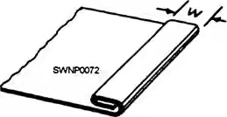**Groove flat lock seam joint:-**The grooves seam joint is one of the most widely used methods for joining light-medium-gauge sheet metal. It consists of two folded edges that are locked together with hand groove.

When making grooved

Figure 5.2.1 shows Groove flat lock seam joint

Chapter 6

Design & calculation

6.1 Modeling:-

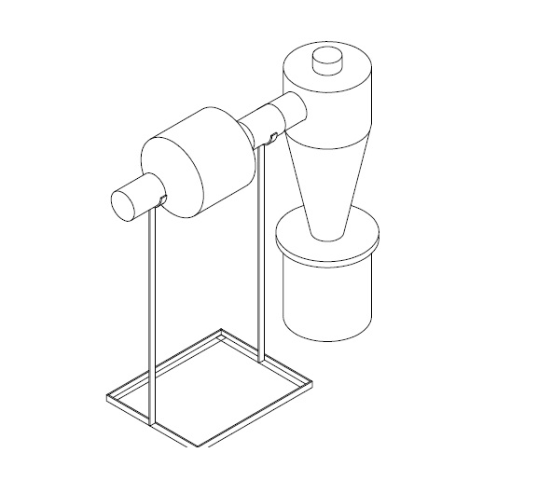

Figure shows 6.1 Autocad 3D line model of cyclone dust collector

**6.2 Design: -** The design of the cyclone dust collector is made according to “The journal Transactions of the American Society of Agricultural Engineers”. All the dimensions of the various components are taken according to the reference barrel diameter in this project.

**6.2.1 Design of the cyclone body:-** 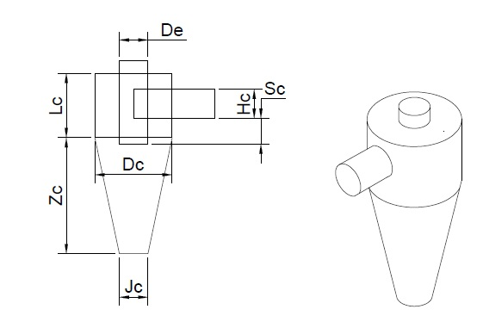

**Figure shows 6.2 diagram of cyclone body**

Reference value Dc = 305 mm

1. =
2. =
3. =
4. =

**6.2.2 Design of fan casing:-**

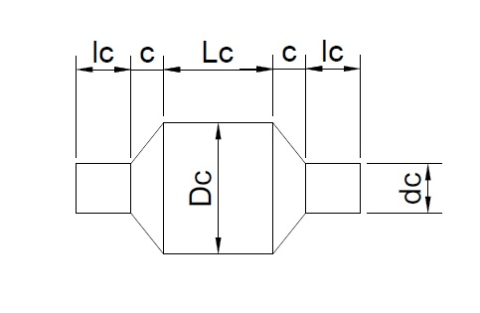

**Figure shows 6.3 diagram of fan casing**

Reference value Fb= Fan blade diameter = 229 mm

**6.3 C**A**LCUL**A**TION: -** Propeller fan provides an economical method to move large air volumes (5000+cfm) at low static pressures (050in. or less). Motors are typically mounted in the air steam which limits applications to relatively clear air at maximum temp of 110 Fo.

# **6.3.1 F**A**N C**A**SING C**A**LCUL**A**TION:-**

1. Room volume= width*height*length

=10*12*10

=1200 feet3

1. CFM calculation: - CFM is short for cubic feet per minute (cu ft/min.).It is a measurement of the velocity at which air flows into or out of space.

CFM

Table 6.4 min/change

|  |  |  |  |  |  |
| --- | --- | --- | --- | --- | --- |
| Area | Min./chg | area | Min./chg | area | Min./chg |
| Assembly Hall | 3-10 | Dance Hill | 3-7 | Machine shop | 3-6 |
| Attic. | 2-4 | Dining Room | 4-8 | Mill | 3-8 |
| auditorium | 3-10 | Dry cleaner | 2-5 | office | 2-8 |
| Bakery | 2-3 | Engine Room | 1-3 | Packing House | 2-5 |
| Bar | 2-4 | Factory | 2-7 | Projection Room | 1-2 |
| Barn. | 12-18 | Foundry | 1-5 | Recreation Room | 2-8 |
| Boiler Room | 1-3 | Garage | 2-10 | Residence | 2-6 |
| Bowling alley | 3-7 | Generator Room | 2-5 | Restaurant | 5-10 |
| Cafeteria | 3-5 | Gymnasium | 3-8 | Store | 3-7 |
| Church | 4-10 | Kitchen | 1-5 | Transfer Room | 1-5 |
| Classroom | 4-6 | Laboratory | 2-5 | Warehouses | 3-10 |
| Club Room | 3-7 | laundry | 2-4 | Rest Room | 5-7 |

V =

V =200 feet/min

V =1.016 m/sec

1. Determine Velocity pressure

VP=

=

VP =2.49

1. Static Pressure (Sp):- Static pressure (SP) is the difference in air pressure between the air inside the duct and the air outside the duct. The result is the suction that allows the collection vacuum system to pick up chips and dust. If you take your hand and move it slowly towards the opening of a vacuum cleaner hose, the hose will pull harder and harder at your hand the closer it gets. When your hand completely covers the opening the static pressure is at its maximum. At this point the airflow (CFM) goes to zero. Static pressure is not suction, but it is what causes suction.

Table 6.5 Static Pressure Guidelines

|  |  |
| --- | --- |
| Non-Ducted | 0.05in. to 0.20in. |
| Ducted | 0.2in. to 0.40in. per 100 feet of duct(assuming duct air velocity falls within 1000-1800 feet per minute) |
| Fittings | 0.08in. per fittings(elbow, register, grill, damper, etc,) |
| Kitchen Hood | 0.625in. to |
| Exhaust | 1.50in. |

Static pressure for ducted=

= 0.3 inch

5. Air Volume=

=2.50

**Fan laws:-**

1. **Fan law 1**
2. **Fan law 2**

=0.846 in

1. To find discharge flow rate of air

Q=

=

=

Q =0.0741

By Continuity Equation

Q =

Q=

0.0741=

7.2216

Calculate Pressure at section 2 hence assume P1=1.0135 bar

+=+ ………………….. (1)

**7) To calculate**

1. Head loss due to sudden enlargement

= =

=1.9627 m

2. Head loss due to sudden contraction

= =

=0.02630 m

Total Loss=1.9627+0.02630

=1.989 m

Put all values in equation (1)

+=++1.989

= …Datum is same

0.0843162+2.6550=+0.05261+1.989

# **6.3.2 CYCLONE BODY C**A**LCUL**A**TION**

Cyclone separators provide a method of removing particulate matter from air streams at low cost and low maintenance. In general, a cyclone consists of an upper cylindrical part referred to as the barrel and a lower conical part referred to as cone (see figure). The air stream enters tangentially at the top of the barrel and travels downward into the cone forming an outer vortex. The increasing air velocity in the outer vortex results in a centrifugal force on the particles separating them from the air stream. When the air reaches the bottom of the cone, an inner vortex is created reversing direction and exiting out the top as clean air while the particulates fall into the dust collection chamber attached to the bottom of the cyclone.

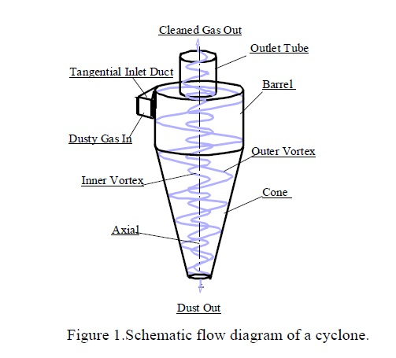

**Figure 6.6 shows schematic diagram of cyclone body**

In the agricultural processing industry, (Shepherd and Lapple, 1939) and (Parnell and Davis, 1979) cyclone designs are the most commonly used abatement devices for particulate matter control.

This dissertation follows the style and format of *the journal Transactions of the American Society of Agricultural Engineers*.

Previous researches (Wang, 2000) indicated that, compared to other cyclone designs, and are the most efficient cyclone collectors for fine dust (particle diameters less than 100 μm).

**1) The Number of Effective Turns (Ne)**

The first step of process is to calculate the number of effective turns. The number of effective turns in a cyclone is the number of revolutions the gas spins while passing through the cyclone outer vortex. A higher number of turns of the air stream result in a higher collection efficiency. The Lapple model for Ne calculation is as follows:

=

**2) Cyclone performance (F):-**

Cyclones are basically centrifugal separators. They simply transform the inertia force of gas particle to a centrifugal force by means of a vortex generated in the cyclone body. The particle laden gas enters tangentially at the upper part and passes through the body describing the vortex. Particles are driven to the walls by centrifugal forces (an expression for this force is given blow eq), losing its momentum and falling down to the cyclone leg. In the lower section, the gas begins to flow radically inwards to the axis and spins upwards to the gas outlet duct.

=

F= 3.11 N

**3) Cut-Point (d50)**

The second step of the process is the calculation of the cut-point diameter. The cut-point of a cyclone is the aerodynamic equivalent diameter (AED) of the particle collected with 50% efficiency. As the cut-point diameter increases, the collection efficiency decreases.

=5.66

=5.66m

1. **Collection Efficiency:-**

# The third step of process is to determine the fractional efficiency. Based upon the cut-point, Lapple then developed an empirical model for the prediction of the collection efficiency for any particle size.

η

=

η=0.7885

η=78.85%

6.4 Fabrication:-

Cyclone body:-

The cyclone body which consists of bottom member cone and the upper member barrel made up of the sheet metal of hollow shape. The cone has dimension of upper diameter of 305 mm and the bottom diameter of 114 mm and height of 458 mm.

Step 1:- The sheet metal is cutted into two parts to make cone as well as the upper barrel. The barrel has dimension of the 305mm diameter and has height of 254mm. Hence the sheet has cutted into dimension of the 965mm*254mm of the sheet part.

Step 2:- The sheet part is then made to make the fold at the free end to have the grooved flat lock seam joined to have the circular shape.

Step 3:- The cone part is the made by pattern making on the sheet metal, which has the bottom hole diameter height and the upper hole diameter.

Step 4:- The pattern is the cutted by the sheet metal cutter and it is joined by the help of the grooved flat lock seam joining method which is used most commonly after that the rivets are hammered on the joint to give the strength to the joint. The bottom side of the cone surface is extended to fasten to the wooden cover by screws.

Step 5:- The metallic ring provide to the barrel top to provide a sufficient strength to the body.

Step 6:- The both barrel and the cone are joined with help of the grooved flat lock seam method of joining. Hence now cyclone body is manufactured.

Step 7:- The PVC pipe of 110mm diameter and length of 170mm is then cutted at the 450 angle. At the centre of the barrel the hole is produced to insert the cutted pipe into it by hand grinding machine.

Step 8:- The pipe is then fixed by the tightening the screws into it and the M-Seal is used to avoid the leakage of air and loosening of the pipe.

**Process sheet:-**

**Part no:-1 Part name: -** Cyclone body **Material: -** Sheet metal

**Quantity:-**1 **Size: -** A 305 mm ×254mm & B 305mm×457mm×114mm

|  |  |  |  |  |  |
| --- | --- | --- | --- | --- | --- |
| **Sr. no** | **Description of operation** | **Machine used** | **Operation** | **Inspection** | **Time**  (min) |
| 1. | Cutting material  A965mm×254mm | Sheet metal cutter | Cutting | Measuring tape | 10 |
| 2. | Cutting material B height 457mm  965mm×114mm | Sheet metal cutter | Cutting | Measuring tape | 10 |
| 3. | Joining the material A ends | Wooden hammer | Joining | Visual | 10 |
| 4 | Make cone pattern 305mm×457mm×114mm | Circle gauge | Pattern making | Measuring tape | 15 |
| 5 | Make Cone | Plate roller machine | Rolling | Visual | 5 |
| 6 | Joining the material B ends | Wooden hammer | Joining | Visual | 10 |
| 7 | Metallic ring to A part | Wooden Hammer | Folding | Visual | 5 |
| 8 | Joining the material Joining A & B part | Wooden hammer | Joining | Visual | 15 |
| 9 | Cutting PVC pipe and make hole in barrel | Hand grinding machine | cutting | Measuring tape | 15 |

Fan casing:-

Fan casing is used for mounting the fan inside the casing and also guide the flow of air and dust particle to the cyclone body. It has central barrel diameter of 305 mm and length of 254 mm according to our design. It has conical part at the both end of small diameter of 114 mm and large diameter 305 mm and length of 100 mm and pipe at both end and connected to cone at 114 mm.

Step 1:- The sheet metal of size 390 mm× 254 mm is cut by using cutter. At the free end of 254 mm of side groove folding is provided. Then both end of groove are joined like grooved flat lock seam by hammering with help of wooden hammer. This will take the shape of circular cylinder.

Step 2:- Pattern is made by cutting the sheet metal of required dimension. After that 2 parts are made adjacent for circular cylindrical casing. One part is connected by grooved flat lock seam. And another part is made like as cover.

Step 3:- Two pipe section made up of sheet metal are connected to both end.

**Part no: - 2 Part name: -** Fan casing **Material: -** sheet metal

**Quantity: -** 1 **Size:-**114mm×305mm×114mm×685mm

|  |  |  |  |  |  |
| --- | --- | --- | --- | --- | --- |
| **Sr. no** | **Description of operation** | **Machine used** | **operation** | **Inspection** | **Time** |
| 1. | Cutting material  A965mm×254mm | Sheet metal cutter | Cutting | Measuring tape | 10 |
| 2 | Joining the material A ends | Wooden hammer | Joining | Visual | 10 |
| 3 | Make cone B pattern | Circle gauge | Pattern making | Measuring tape | 15 |
| 4 | Make Cone | Plate roller machine | Rolling | Visual | 5 |
| 5 | Make small pipe  114mm*127mm | Plate roller machine & hammer | Rolling & hammering | Visual | 5 |
| 6 | Joining the material Joining A , B&C part | Wooden hammer | Joining | Visual | 20 |

Fan Ring:-

Circular ring is used to mount the fan and its supports to the casing. It has diameter 305mm and it is situated in the casing. It is manufactured by welding process.

Step1:-First of all we take the flat 12mm strip of length is 965.2mm is hammered on anvil and given the shape of circular ring with help of hammer. And then both the end of the circular ring is welded with help of welding machine.

Step2: -Flat 12mm width of strip of length 406mm is cutted into 4 small strips and these strips are welded to inner ring surface 900 apart.

Step3:- The drilling operation is carried out on the free end of these 4 strips to support the fan in fan casing.

Step4:- Grinding operation is carried out for removing the sharp edges formed during the welding process.

**Part no: - 3 Part name: -** Fan ring **Material: -** C.I

**Quantity: -** 1 **Size: -** 305mm×114mm

|  |  |  |  |  |  |
| --- | --- | --- | --- | --- | --- |
| **Sr. no** | **Description of operation** | **Machine used** | **operation** | **Inspection** | **Time** |
| 1. | Cutting material  L=965mm | Electrical Circular saw metal cutter | cutting | Measuring tape | 3 |
| 2 | Make ring  305mm diameter | Hammer | Hammering | Visual & Measuring tape | 10 |
| 3 | Cutting material  L=406mm into four strips | Electrical Circular saw metal cutter | cutting | Measuring tape | 10 |
| 4 | Welding strips to ring | Electric arc welding machine | Welding | Measuring tape | 10 |
| 5 | Drilling hole | Hand drilling machine | drilling | Visual & Measuring tape | 10 |

Wooden plates:-

Step 1:- The wooden plywood of dimension 1220mm*356mm is cutted into three parts by the wooden cutting machine. The first part is then marked by the pencil of the diameter 305mm and inside diameter of 114mm. then the plywood first part is the mounted on the cutting machine then the hand drill is used to start the point of cutting, then the cutting begins and the part is then made as required.

Step 2:- The second & third part has dimension of the 305 mm diameter and 100mm inner diameter are also made by above method.

Step 3:- The part one and third is joined by nails by the help of the hammer to make the cover to the collecting bucket.

**Part no: - 4 Part name: -** Wooden plate **Material: -** Plywood

**Quantity: -** 3 **Size: -** 1220mm×356mm

|  |  |  |  |  |  |
| --- | --- | --- | --- | --- | --- |
| **Sr. no** | **Description of operation** | **Machine used** | **operation** | **Inspection** | **Time** |
| 1. | Cutting material  L=1220mm×356mm | Electrical Circular saw wood cutter | cutting | Measuring tape | 5 |
| 2 | Make circular plate  A) OD=355mm  ID=114mm | Jigsaw | cutting | Visual & Measuring tape | 10 |
| 3 | Make circular plate  B) OD=305mm  ID=114mm | Jigsaw | cutting | Visual & Measuring tape | 10 |
| 4 | Make circular plate  C) OD=305mm  ID=114mm | jigsaw | cutting | Visual & Measuring tape | 10 |
| 5 | Joining A & B | Hammer | Nailing | Visual tape | 10 |

Support stand:-

Support stand is used to support the fan casing. Fan casing is mounted on stand. The support stand has dimension of height of 927mm *584mm*304mm.

Step 1:- The C.I rods of 2600 mm are cutted to have our necessary dimensions 927mm two rods and 584mm 305mm each two rods.

Step 2:- The 584mm and 305mm rods re welded by means of the welding machine to have base frame of 584mm×305mm dimensions.

Step 3:- The two rods of 927mm re welded at the centre of the 305mm rods vertically.

Step 4:- To have good strength to the vertical rods at the centre.

Step 5:- The hand grinding operation is carried out for removing the welding deposits at the welding section.

**Part no: - 5 Part name: -** Support stand **Material: -** C.I

**Quantity: -** 1 **Size: -** 927mm ×584mm×304mm.

|  |  |  |  |  |  |
| --- | --- | --- | --- | --- | --- |
| **Sr. no** | **Description of operation** | **Machine used** | **operation** | **Inspection** | **Time** |
| 1. | Cutting material  L=927mm | Electrical Circular saw metal cutter | cutting | Measuring tape | 10 |
| 2 | Cutting material  L=584mm | Electrical Circular saw metal cutter | cutting | Measuring tape | 10 |
| 3 | Cutting material  L=304mm | Electrical Circular saw metal cutter | cutting | Measuring tape | 10 |
| 4 | Welding to make frame  927mm*584mm*304mm | Electric arc welding machine | Welding | Measuring tape | 10 |
| 5 | Grinding operation | Hand grinding machine | Grinding | Visual | 10 |

Chapter 7

Cost Estimation

Cost estimation may be defined as a process of forecasting the expenses that must be incurred to manufacture a product. These expenses take into a consideration all expenditure involved in a design and manufacturing with all related services facilities.

**Purpose of cost estimating:**

1. To determine the selling price of a product for a quotation or contract so as to ensure a reasonable profit to the company.
2. Check the quotation supplied by vendors.
3. Determine the most economical process or material to manufacture the product.
4. To determine standards of production performance that may be used to control the cost.

**Material cost estimation**

Material cost estimation gives the total required to collect the raw material which has to be processed or fabricated to desired size and functioning of the component.

Procedure

The general procedure for calculation of material cost estimations

1. The rates of all standard items are taken and added up.
2. Cost of raw material purchased taken and added up.

**Material cost estimation table**

Therefore the cost of materials is as follows:

|  |  |  |  |  |
| --- | --- | --- | --- | --- |
| **Sr. No** | **Name of components** | **Quantity** | | **Cost**  **(in rupees)** |
| 1. | Exhaust Fan | 1 | | 1150 |
| 2. | Cyclone Body | 1 | | 500 |
| 3. | Fan Casing | 1 | | 400 |
| 4. | Flexible Pipe | 1 | | 450 |
| 5. | Support Stand | 1 | | 400 |
| 6. | Ply Wood | 3 | | 250 |
| 7. | Fan Ring | 1 | | 120 |
| 8. | PVC Pipe | 1 | | 100 |
| 9. | M-Seal | 3 | | 80 |
| 10. | Nut and Bolts | 8 | | 20 |
| 11. | Fasteners | 10 | | 48 |
| 12. | Collection Bucket | 1 | | 50 |
| **Total cost** | | | 3,568 | |

Therefore the total cost of the project is **rupees 3,568**

Chapter 8

Testing & observation

**8.1 Testing:-**

The all the components are assembled properly and the cyclone equipment is positioned near to the spinning machine (shown in figure 8.1) the flexible pipe inlet is subjected to the area where the emission is happening. When the exhaust fan is ON it creates suction inside the casing inlet. When the inlet pipe is kept near the dust emission section the dust particle tend to get sucked inside the casing and moved forward toward the cyclone inlet. The dust particle inside the cyclone body moves tangentially because of centrifugal force of particle. The all the particle settled down in the collecting chamber. The all the required reading are noted down in observation table.

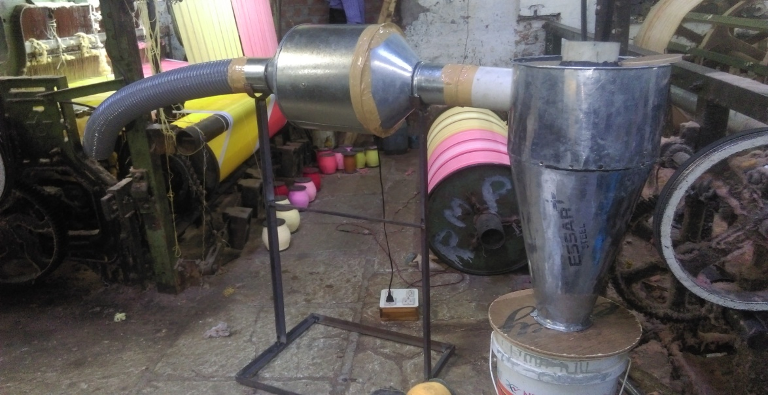**Figure 8.1 shows experimental setup of cyclone dust collector**

**8.2 Observation table:-**

|  |  |  |  |
| --- | --- | --- | --- |
| Sr no. | Input dust  (gm) | Quantity of dust collected in bucket(gm) | Efficiency  (%) |
| 1 | 100 | 75 | 75 |
| 2 | 200 | 148 | 74 |
| 3 | 300 | 221 | 73.6 |
| 4 | 400 | 295 | 73.75 |
| 5 | 500 | 368 | 73.6 |
|  |  | Average Efficiency= | 73.99 |

From the observation table we can observe that average efficiency is 73.99%. The 73.99% of dust is prevented to emit into the atmosphere.

**Table 8.1 Comparison between cyclone dust collector and Market dust collector**

|  |  |  |
| --- | --- | --- |
| **Specifications** | **Cyclone dust collector** | **Market cyclone dust collector** |
| **Cost(Rs)** | 3568 | 60000-65000 |
| **CFM** | 336 | 2000 |
| **Filter used** | No | Used |
| **Portable** | Easy to assemble & disassemble | Requires skilled operator to assemble. |
| **Rotating part** | Exhaust fan used | Centrifugal air blower |
| **RPM** | 2350 rpm | 4500 rpm |
| **No. of Part used** | 9 | 15 |
| **Efficiency** | 73.99 | 90-95 |

Chapter 9

Conclusion

Form the result it is observed that 73.99% of dust has been collected inside the dust collector drum. Hence amount of dust collected is measured on weighting machine and we can conclude that amount of collected dust is been resisted to enter into the environment. And healthy environment can be created, workers life span increases.

The our objectives are achieved

1. Low manufacture cost.
2. Good collecting efficiency.
3. Healthy environment is created.

Future Scope

The project aim is to collect the fabric dust particle to prevent the emission of dust particle to enter into the environment to create healthy atmosphere. To reduce the cost of manufacturing.

These objectives are achieved but there are some situation like bucket filling meter, filter, remote to ON or OFF and some of dust stick inside the fan casing. For making correction some future work have to be done. Following are some given

1. Add filter at exit pipe of cyclone to improve efficiency.
2. This project can be used in wood working shop.
3. In future this can be modified as more efficient and economical.
4. Provide measuring meter or sensor to the collecting bucket to sense amount dust collected into the bucket.
5. Solar energy can be used to reduce energy consumption.

References

[1] Theoretical study of cyclone design Dissertation by Lingjuan Wang.

[2] Mahesh R Jadhav [ISSN 2278 – 0149 ([www.ijmerr.com](http://www.ijmerr.com)) Vol. 3, No. 4, October, 2014]

[3] Qizhen Liu, Yanking Sun, Lei Jia, Yihua Zhang, and Zhigang Shen [Journal of Clean Energy Technologies, Vol. 3, No. 2, March 2015]

[4] Muhammad I. Taiwo. Mohammed A. Namadi. And James B. Mokwa [AJER]

[5] Journal of the Air Pollution Control Association (Charles A. Gallaer & J. W. Schindeler)

[6] Analysis and Optimization of Cyclone Separators Geometry Using RANS and LES Methodologies by (Khairy Elsayed)

[7] Flow through pipes Dr. R K Bansal page 465 to page 483